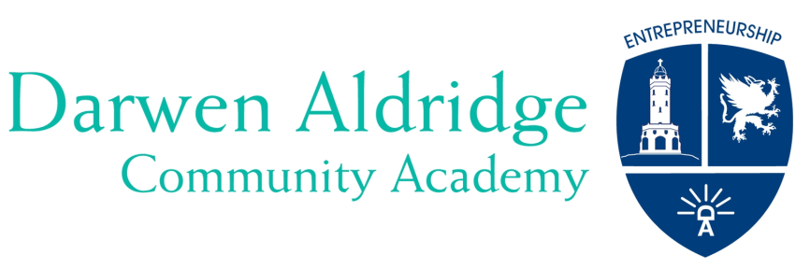

Darwen Aldridge Community Academy & Sixth Form
Sudell Road, Darwen, Lancashire BB3 3HD
Tel: 01254 819500 Fax: 01254 819501
Student Services: 01254 819540
www.daca.uk.com
email: info@daca.uk.com

‘Realise your potential’

September 2020
Dear Parent/Carer,
Thank you for your interest in our Academy and for your child to join us in September 2021. In 2017 we were delighted for Ofsted to have judged that ‘the school continues to be a good school’ where the students ‘clearly enjoy and very importantly value their education.’ Our sixth form has been in the top 10% of all schools nationally for the last 5 years and our results are consistently excellent.
We would like to extend a warm invitation to our Open Evening on Thursday 24th September 2020 from 5.00pm. Due to the current restrictions and to keep everyone in our academy and wider community safe from coronavirus, we are having to host this event virtually. Our Open Evening will still offer prospective Year 7 students and parents an opportunity to find out more about the Academy. You will be able to take a virtual 360 tour, find out about our ethos, our successes and the exciting range of opportunities and facilities that are available within the Academy.
You will be able to access the event on http://dacatour.co.uk/ where you will hear from the Principal, the Directors of Learning for each faculty, some of the Senior Leadership Team and some of our students who will all explain what makes the Academy such a great place in which to work and learn. We will be pleased to answer your questions on all aspects of Darwen Aldridge Community Academy via a live chat function which will be available on the same page between 6pm and 7pm on 24th September.
If you are unable to attend the Virtual Open Evening, the link will remain active and so you can view at any convenient time after the event.
Please be aware that in each of the last three years, we have been oversubscribed with significantly more applications than places available. Most parents who missed out on securing places did so because they did not meet the deadline for the return of applications for places. The deadline is 31st October 2020 and applications for places in our Academy are made through the BwD application for school places process. Please ensure that that you do not miss the deadline. It is also worth noting that historically, every application that has placed the Academy as a first preference has secured a place. Should you have any queries about admission or the transition process, please email rachel.lewis@daca.uk.com
We look forward to you attending our Open Evening. Please do not hesitate to contact us if you have any questions. Prior to the event, you can view our Academy Prospectus which will give you more information about the Academy. You can access this on our website www.daca.uk.com by clicking the ‘About’ button and then ‘Prospectus’.
Yours sincerely,
Lisa Dolan
Principal

