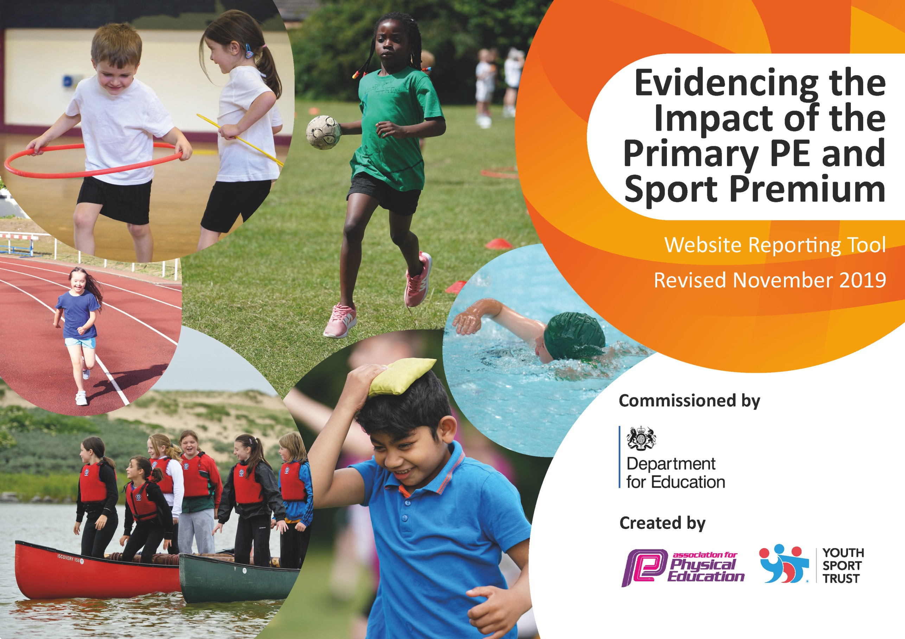
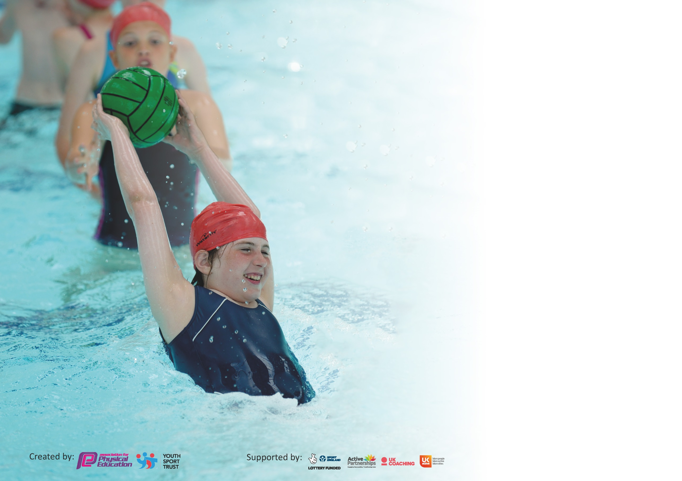

It is important that your grant is used effectively and based on school need. The Education Inspection Framework (Ofsted 2019 p64) makes clear there will be a focus on ‘whether leaders and those responsible for governors all understand their respective roles and perform these in a way that enhances the effectiveness of the school’.

Under the Quality of Education criteria (p41) inspectors consider the extent to which schools can articulate their curriculum (INTENT), construct their curriculum (IMPLEMENTATION) and demonstrate the outcomes which result (IMPACT).

To assist schools with common transferable language this template has been developed to utilise the same three headings which should make your plans easily transferable between working documents.

Schools must use the funding to make additional and sustainable improvements to the quality of Physical Education, School Sport and Physical Activity (PESSPA) they offer. This means that you should
use the Primary PE and Sport Premium to:

- Develop or add to the PESSPA activities that your school already offer
- Build capacity and capability within the school to ensure that improvements made now will benefit pupils joining the school in future years

Please visit gov.uk for the revised DfE guidance including the 5 key indicators across which schools should demonstrate an improvement. This document will help you to review your provision and to report your spend. DfE encourages schools to use this template as an effective way of meeting the reporting requirements of the Primary PE and Sport Premium.

We recommend you start by reflecting on the impact of current provision and reviewing the previous spend.

Schools are required to publish details of how they spend this funding as well as on the impact it has on pupils’ PE and sport participation and attainment by the end of the summer term or by 31st July 2020 at the latest.

We recommend regularly updating the table and publishing it on your website throughout the year. This evidences your ongoing self-evaluation of how you are using the funding to secure maximum, sustainable impact. Final copy must be posted on your website by the end of the academic year and no later than the 31st July 2020. To see an example of how to complete the table please click HERE.

Support for review and reflection - considering the 5 key indicators from DfE, what development needs are a priority for your setting and your pupils now and why? Use the space below to reflect on previous spend and key achievements and areas for development.

Key achievements to date until July 2019: | Areas for further improvement and baseline evidence of need:
- Wide range and variety of after school clubs across the different key stages throughout the year.  - Opportunities for SEN children in competitions and Festivals.  - Evidence of a wide range of P.E lessons  - Working towards Gold Sports Award.  - Success in Year 5/6 Football Events – Winners of Darwen school league, EFL Kids cup Winners, BRCT Football Cup Competition Winners. Representing Darwen - Lancashire Cup.  - Success in Cross Country Events. | - Continue with programme of P.E CPD for teachers to further improve and sustain high quality teaching.  - Sharing of ‘good practice’ from CPD courses to fellow teachers and other members of staff in school.  - Improve participation in KS2 girls in clubs – School staff member to take on the club.  - Further improve opportunities for KS1 after school clubs.  - Improve participation of PP/SEN in after school clubs.  - Recovery and catch up –KS1 Fundamemtal Kids Club for Autumn Term  - Continue to work towards – Gold Award.  - Introduce a sports council.  - Update Subscription to association for Physical Education.

Meeting national curriculum requirements for swimming and water safety.
What percentage of your current Year 6 cohort swim competently, confidently and proficiently over a distance of at least 25 metres?  N.B. Even though your pupils may swim in another year please report on their attainment on leaving  primary school at the end of the summer term 2020. | 60%
What percentage of your current Year 6 cohort use a range of strokes effectively [for example, front crawl, backstroke and breaststroke]? | 74%
What percentage of your current Year 6 cohort perform safe self-rescue in different water-based situations? | 98%
Schools can choose to use the Primary PE and Sport Premium to provide additional provision for swimming but this must be for activity over and above the national curriculum requirements. Have you used it in this way? | No

Action Plan and Budget Tracking
Capture your intended annual spend against the 5 key indicators. Clarify the success criteria and evidence of impact that you intend to measure to evaluate for pupils today and for the future.

Academic Year: 2019/20 | Total fund allocated: £18,502 | Date Updated: July 2020
Key indicator 1: The engagement of all pupils in regular physical activity – Chief Medical Officer guidelines recommend that primary school pupils undertake at least 30 minutes of physical activity a day in school |  |  |  | Percentage of total allocation:
 |  |  |  | 30%
Intent | Implementation |  | Impact
Your school focus should be clear what you want the pupils to know and be able to do and about  what they need to learn and to  consolidate through practice: | Make sure your actions to achieve are linked to your intentions: | Funding allocated: | Evidence of impact: what do pupils now know and what can they now do? What has changed?: | Sustainability and suggested next steps:
Children to access quality PE lessons through specialist coaching.  Children physical for 30 minutes a day with the walk a Km exercise programme. | BRCT - School PE Provision  Ensure sports coaches plan and deliver quality PE lessons across the different key stages. Support children in developing their fundamental skills. Build relationships with children, to promote the enjoyment of PE and sport and encourage participation at after school and outside clubs.  Staff rota given to have a staff representation on the daily walk a KM programme.  Certificates presented termly, Gold, silver, bronze. Additional opportunity for 50 minutes activity every week. | 5,540.00  30.00 | All children make good progress within PE lessons.  Year 1- 78%  Year 2- 93%  Year 3 – 70%  Year 4 – 89%  Year 5 – 88%  Year 6 – 86%  Data EYFS/KS1  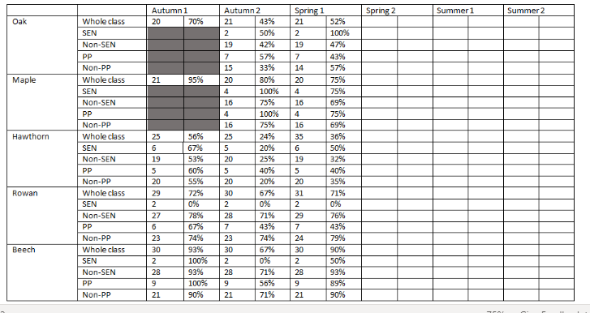  Oak -52% Maple- 75% Hawthorn- 36% Rowan- 71% Beech – 90%  Data KS2  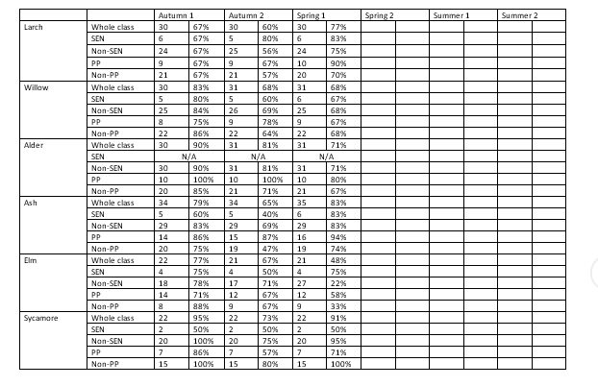  Larch – 77% Willow – 68%  Alder – 71% Ash – 83% Elm -48%  Sycamore – 91% | After Lesson observations and CPD requirements. Next year 2 x lunchtime clubs and 4 x curriculum session and 2 x after school clubs will be provide by NS from Little Lions Coaching clinic costing £9,540.00  Continue with staff Rota and praising and promoting with Termly certificates. £30.00.
Key indicator 2: The profile of PESSPA being raised across the school as a tool for whole school improvement |  |  |  | Percentage of total allocation:
 |  |  |  | 0%
Intent | Implementation |  | Impact
Your school focus should be clear what you want the pupils to know and be able to do and about  what they need to learn and to  consolidate through practice: | Make sure your actions to achieve are linked to your intentions: | Funding allocated: | Evidence of impact: what do pupils now know and what can they now do? What has changed?: | Sustainability and suggested next steps:
Increase motivation of pupils in PE.  . | Blackburn Rovers player visit  Visit from 2 first team Blackburn rovers Players. Question and answer session, Player working in PE sessions and talking about their school experiences of PE and sport in school. Inspiring pupils to participate more in physical activity. Through lunchtime and after school clubs.  Evidence seen in extracurricular clubs. | (benefit from Blackburn rovers Community Trust School PE Provision – Amount Allocated in section 1) | See photos  Conferencing with children  Attendance of clubs  Boys School Football Team  - 19-20 Darwen school league winners  - Regional Winners for The EFL kids cup. -Opportunity to represent Blackburn Rovers in the Regional Finals  - Winners of the CVL CUP  - Represent Darwen in the Danone Cup at Fleetwwod Town.  - 2 children selected to represent the town team.

Key indicator 3: Increased confidence, knowledge and skills of all staff in teaching PE and sport |  |  |  | Percentage of total allocation:
 |  |  |  | 4%
Intent | Implementation |  | Impact
Your school focus should be clear | Make sure your actions to | Funding | Evidence of impact: what do | Sustainability and suggested
what you want the pupils to know | achieve are linked to your | allocated: | pupils now know and what | next steps:
and be able to do and about | intentions: |  | can they now do? What has
what they need to learn and to |  |  | changed?:
consolidate through practice:
Increase skills and confidence of teaching staff in different PE areas of the curriculum.  Use skills and knowledge gained from CPD course to provide sports club and participate in competition/event/festival.  Audit, organise and replenishing PE resources.  To work with Whittaker’s school clothing shop to offer an outdoor PE kit for the children to wear in the outdoor PE session. | Provide CPD to staff.  Gymnastics course attended by ET.  Led to Team Teaching in PE lesson – Lesson observation good quality teaching observed.  GC – attended PE assessment  NT – KS1 Fundamental skills  Staff and children need to have good working equipment to provide good to outstanding PE lessons. Children should be able to work individually or in pairs with equipment.  More PE lessons to take place outside using the large outdoor environment we have on our school grounds. | £125.00  464.75  120.00  N/A | CPD impact form.  86% of children secure and above in year 6 due to opportunities given and quality teaching.  Gymnastics club run for both UKS2 and LKS2 – Gymnastic competition entered.  End of club evaluation.  All children able to participate in all lessons with whole class equipment. Staff have all equipment needed to carry out high quality lessons.  Children to be dressed appropriate to take part in quality PE lessons with correct PE wear. | ET to gain extra hours @ £11.65 per hour.  To use ET to team teach Gymnastics and Dance across the year groups next academic year, to provide CPD to all KS2 teachers.  Continue to run club for KS2 and offer to KS1.  Audit to be given to all staff and location (indoor or outdoor) so they know where to locate equipment needed for PE lessons or club.  Contact Whittaker’s school wear and notify parents.
Key indicator 4: Broader experience of a range of sports and activities offered to all pupils |  |  |  | Percentage of total allocation:
 |  |  |  | 34%
Intent | Implementation |  | Impact
Your school focus should be clear | Make sure your actions to | Funding | Evidence of impact: what do | Sustainability and suggested
what you want the pupils to know | achieve are linked to your | allocated: | pupils now know and what | next steps:
and be able to do and about | intentions: |  | can they now do? What has
what they need to learn and to |  |  | changed?:
consolidate through practice:
Additional achievements:  Introduce children and families to a wider range of sports.  Raise the profile of sport and sporting events in school.  KS1 Fundamental skills Club  Gymnastics club For UKS2 and LKS2  Match day Experience at Blackburn Rovers with Save a life First Aid training. | Ice Hockey Visit  Whole school Assembly – Children introduced to the sport of Ice Hockey. Demonstrate of equipment used, talk on the success of the local club, Blackburn hawks. Opportunity for families to attend an ice hockey match and have a go at ice skating for just £1 entry.  BRCT After School Provision – Run after school clubs 4 days a week.  Use the events calendar from the school games provider, DPSSA and BRCT to plan a yearly timetable of events /competitions and festivals to attend.  Opportunity for children to be involved in a variety of sports.  Invites to BFRC Fixtures.  To target children (Invite to the club) Struggling with the fundamentals in EYFS & Year 1.  Extra Staff x1 to support with SEN needs in the club.  Club run over 2 terms to work towards a routine and school Gymnastics team to represent the school in the Key Steps Gymnastics Competition.  Invitation from BRFC to a match Day experience forming the guards of honour as the player came out on the pitch. Before the match having first aid training from St Johns Ambulance. | N/A  £6,048.00  £54.00  (only 2 session )  Spring Term  LR- £24.50  ET – 11.65 x12  Experience through the BRCT PE provision. | 43% of the school and their families bought tickets and experienced another local sport.  Pupil conferencing – Experience of the Ice hockey  Percentage of children attending Clubs  Year 6 – 52%  Year 5 – 43%  Year 4 – 45%  Year 3 – 48%  Year 2 – 9%  Year 1- 35%  PP Children  Year 6 – 43%  Year 5 – 33%  Year 4 -30%  Year 3 -29%  Year 2 – 50%  Year 1 – 29%  SEN Children  Year 6 – 9%  Year 5 -13%  Year 4- 10%  Year 3 -10 %  Year 2 – 0%  Year 1 -7%  BRCT Events Attended  KS2 SEND  Year ¾ Athletics  Year3/4 orienteering  Year 5.6 Rugby  None attended from April due to COVID-19  Year 5/6 High 5s Mixed Netball  Year 5/6 Girls Football  Year 5/6 Boys Football Competition – Finished Winners  Not able to measure the impact due to COVID-19  Children confident in gymnastic routines required for competition. Children able to should talents from weekend clubs. Attitude and commitment to club with an end goal- competition.  Children provide with a live match day experience. Learning Valuable First aid Skills.  St Peters child pick to be mascot for contribute to questions and answers during first aid training.  See Photo’s  Pupil Conferencing | Made contact with Sporting NRG before COVID-19. Planned to offer a range of after school clubs including  Archery and Canoeing.  Look to start in Autumn 2020  Provide a wider range of opportunities by using a variety of providers such as  Sporting NRG  Little Lions Sporting Clinic  Tag Sports North West  BRCT  More after school clubs planned for Summer term for KS1 – Not achieved due to covid-19  Tag sports North west – to run a KS1 Fundamental skills after school club. £54.00 paid for 2 weeks before lockdown 2020.  More sessions needed.  Assess to KS1 on return to school when safe to do so.  ET to continue to run Gymnastics After school club.  Children to deliver skills learnt to whole class. Look into St John’s Ambulance provide whole class year 6 training.

Key indicator 5: Increased participation in competitive sport |  |  |  | Percentage of total allocation:
 |  |  |  | 7%
Intent | Implementation |  | Impact
Your school focus should be clear | Make sure your actions to | Funding | Evidence of impact: what do | Sustainability and suggested
what you want the pupils to know | achieve are linked to your | allocated: | pupils now know and what | next steps:
and be able to do and about | intentions: |  | can they now do? What has
what they need to learn and to |  |  | changed?:
consolidate through practice:
More pupils taking part in school and out of school competitions.  More pupils representing school teams in games situations and competitions.  Pupils have access to transport to be able to attend sporting events. | Buy into school Games Organiser Basic Package.  End result for an after school club- opportunity to represent school in a competition or a festival.  To continue to develop a working relationship with the school games organisers Phil Eastwood and Andrew Mercer. To communicate with and have knowledge of the school games competitions and festivals for the year. Using this knowledge provide after schools clubs (link with BRCT) teach skills and knowledge for the different competitions/festivals which we enter.  Respond to emails to enter and understand rules for the competitions. Create a yearly competition calendar. Link this involvement to after school clubs to be run and skills taught in PE Lessons through Games.  DPSSA  Darwen Primary Schools Sports Association.  Attend termly meetings to discuss times and dates of the next Darwen schools Events.  During this time it allows you to meet with other PE co-ordinators and the school games organisers (as above) to ensure good quality and successful sporting events are made available and accessible to all Darwen schools.  Taxi/minibus hire to transport children to and from events during school time. | £850.00  £505.29 | Pupil Questionnaires  Competitions and events attended:  KS1 Multi skills  Year3/4 Dodgeball festival  Year 5/6 Dodgeball Festival  Boccia Festival  Year ¾ sporthall Athletics  Year5/6 Sportshall athletics  Year3/4 key steps Gymnastics  Year 5/6 B/C/D football  Year 5/6 Cycling  Year 5/6 Orienteering  From this Darwen Primary Schools Sports Assosiation as a school we participated in:  DPSSA Girls Netball  DPSSA Boys Football  DPSSA Cross Country  DPSSA Girls Football  DPSSA Swimming Gala  Allows greater participation in events. | To continue to buy into school games Organisers basic package. Provide an end result for an after school club – opportunity to represent school in a competition or a festival.  Increase Participation for SEN and PP Children through festivals.  Continue with the DPSSA

Signed off by
Head Teacher: | Mrs V Weddle
Date: | 21.9.20
Subject Leader: | Mrs G Clanford
Date: | 7.9.20
Governor: | Laura Jenkinson
Date: | 22.9.20

